**22 Aug 2014** **The Weekly Bulletin of Rotary Club of Kathmandu Mid-Town** **bc-08/8.014**

|  |
| --- |
|  |

District: 3292 Web:www.rotarymidtown.org.np Club Id: 26776

**AUGUST IS MEMBERSHIP & EXTENSION MONH**

**Celebrating**

**25 Years in Rotary**





Friday, 15 August : Extracts of the Minutes # 1242

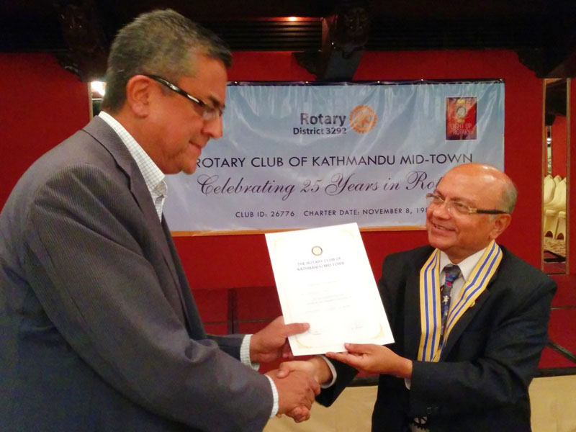

Speaker Rtn Radesh receiving Letter of Appreciation from President Kul

“Rtn Rabi introduced the In House Guest Speaker Rtn Radesh Pant who

currently heads the Nepal Investment Board. Mr. Pant spoke about

investment climate in Nepal.

“Mr. Pant gave an introduction to the Investment Board. He spoke about

the prospect of infrastructure projects. He said that Nepal lacks good

contract management which is vital for big investment proejects.

He said that energy can also be easily tradeable at the counter. ‘It is

necessary to ensure PDA is bankable’. Mr Pant said that without strong

PTA with India there will be no foreign investors and that Nepal has

limited capacity to look at risks. ‘It is necessary to break the monopoly

of NEA’.

“Rtn Buddha, Rtn Shankar, Rtn Saroj, Rtn Ranjit, Rtn Bhairaja & Mr Sanjib took part in the discussion. Rtn Lisa gave vote of thanks.”

><><><><><><><><

Information Sharing:

- President Kul exchanged RCKMT flag with visiting Rtn Dr Werner Krapf, RC Weissenhover.

- PP Ambika handed over the flag of RC, Menlo Park, CA to the President.

- Rtn Bhairaja announced that Guest Speaker for next meeting, 22 August, is Ms Sangita Shrestha. The Guest Speakers for September are Dr Bekh B Thapa, Mr Pitambar Sharma and the Chief of Army Staff.

- President Kul, PP Ajay, PP Mani and PP William will be joining the membership seminar on 16 August.

- Members present in the meeting: 28

- Membership fee paid by 30 out of 50 members.

><><><><><><><><

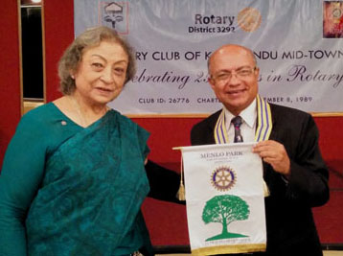

PP Ambica presenting club banner of

RC Menlo Park, CA to President Kul

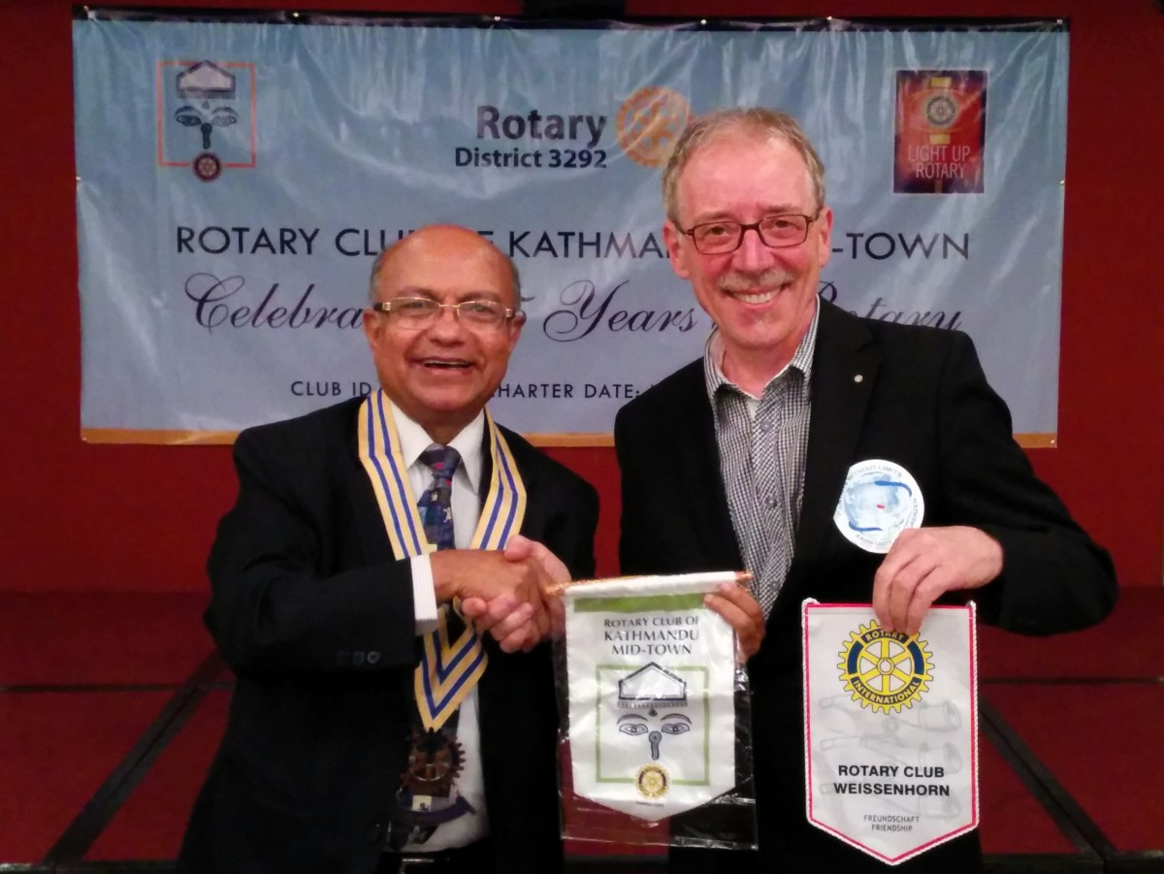

President Kul and visiting Rtn Dr Werner Krapf,

RC Weissenhover, busy exchanging club banners

# Weekly Meetings and Prorams :

|  |  |  |
| --- | --- | --- |
| Date | Program/Speaker | Program/Topics of Presentation |
| 22 August | Sangita Shrestha | ?? |
| 29 August | Club assembly | Review and discussion on Club matters/projects |
| 5 September | Craig Sanders, UNHCR Rep |  |

Friday, 22 August :

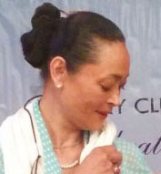

Ms Sangita Shrestha Einhaus, a proven and renowned name in the travel/hospitality

business, will be our guest speaker.

She is the daughter of our PP Ambica Shrestha. She is the MD of at least 5 companies.

“[The traveler sees what he sees, the tourist sees what he has come to see.](http://www.brainyquote.com/quotes/quotes/g/gilbertkc100091.html)”

[Gilbert K. Chesterton](http://www.brainyquote.com/quotes/authors/g/gilbert_k_chesterton.html)

**Mid-Town Membership Increase:**

There is a good news! Rotary Club of Kathmandu Mid-Town is going to add 4 new members. Dr Shankar Sharma, Mr Sanjib Rajbhandari, Ms Sangita Shrestha Einhaus and Ms Sheri Meyerhoffer are going to be inducted soon.

Excepting Sheri none of them are new faces to the Club. Dr Sharma was Mid-Towner before he went to the USA to take up the assignment as the Ambassador of Nepal to the United States. After completing his term he returned Nepal in Jan 2014 and has already joined the Club; Mr Sanjib Rajbhandari was also a Mid-Towner. He was in vacation, (a pretty long vacation!) and is now coming back home! Ms Sangita Einhaus Shrestha is also not a new face. She is the daughter of our PP Ambica Shrestha and the spouse of Rtn Remigius Einhaus who has been visiting our Club every year whenever he comes to Kathmandu.

Ms Sheri L Meyerhoffer was our guest speaker recently.

Be ready for a big welcome !

**Krishnashtami**: 17 August

Bhagavan Krishna, the eighth incarnation of the Hindu god Vishnu, lived in the third

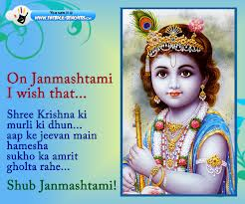

Millennium before Christ. He was an Avatar or divine incarnation. The historical facts of

Krishna's life are interwoven with a maze of legend and mythology.

The universal teachings of Lord Krishna have been written down in the Bhagvad Gita.

On the surface, Krishna's counsel is gloriously edifying in its simplicity and can shed

light on the path of any man in any age or clime. A deeper study reveals the pathway

to God-realization through yoga techniques of meditation and attunement with the

cosmic laws of right action. The path advocated by Bhagavan Krishna is the moderate,

medium, golden path, both for the busy man of the world and for the highest spiritual

aspirant.

*Source:* Internet News

**District 3292 News:**

- District Membership Development Seminar was held on Saturday, 16 Aug. It was decided in the Seminar that whatever money saved in the Seminar was to be handed over to the disaster relief call of the nation.

- Four districts in Western Nepal: Banke, Bardiya, Surkhet and Dang are severely affected by floods and landslides. Floods and landslides victims of the area require immediate support for ready to eat food and other support. Rotarians in Dang, Tulsipur and Dhangadhi are doing their best in local relief efforts. In Dhangadhi 3 Rotary Shelter boxes have been given to District Administration office and some food items are provided for immediate help to the victims.

Local contact for coordinating relief help is Mr. Krishna P. Acharya, Asst CDO, Banke, M: 98580-22111/98580-34488

**Floods and landslides**



On Lighter Side :





Great Quotes:

*Patience with spouse and children is love,*

*Patience with friends and colleagues is respect.*

*Patience with time is determination*

*Patience with mistakes is experience*

*Patience with oneself is confidence.*

*Have patience and be happy in life !*

Inviting our spouses into Rotary isn't just about getting our numbers up. It addresses the reality

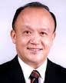

that Rotary still has far more men as members than it does women, and that is something we need to work on. When we bring more women into Rotary, our clubs become more appealing to

prospective female members – and become more productive as well.

**RI President GARY C.K. HUANG**

Please send information on club activities, progress reviews on service projects, relevant photos etc to:

BC Editor: RR Shrestha email: rryesrr@gmail.com

## 22 August 2014 The Weekly Bulletin of Rotary Club of Kathmandu Mid-Town bc-08/8.014

In-house speaker Rtn Radesh Pant gave a brief talk on Investment

Board and investment climate in Nepal.

Investment Board Nepal (IBN) was established in November 2011, under

Investment Board Act, 2068, chaired by the Prime Minister.

IBN was set up to fast-track large scale projects (Rs. 10 bn and above)

and projects stipulated by the Act by granting approvals, as well as

mobilizing and managing public-private partnership.

IBN also provides one-window service with investors, creates investor

friendly environment, and promotes Nepal as an investment destination.

Rtn Radesh also provided some highlights of Project Development

Agreement. It is founded on the four pillars - nine PDA principles,

acceptable and workable risk allocation, the project is bankable, and international precedents to ensure a sustainable agreement.